From the video in your file : "Public > ETLV > Sustainability" and in your Moodle, answer the questions below. What is Sustainability? 🌎🌍🌏 from 0:18 to 1 minute.

- Broad Definition
Sustainability is about the meeting of ………………….. of the present without ………………………... the ability of future generations to ………………………………………….eet their needs.
- Different types of “sustainability”

- Give details about “environmental sustainability” “when we think about environmental sustainability…”

- Ozo

- ne depletion
- What are the solutions ?

*From English to French
- The needs : - ecosystem collapse :
- depletion : - renewable :

Give an ENGLISH definition of the word RECYCLING : the activity of treating materials or products using a special industrial process so that they can be used

VOCABULARY TEST
- Translate from French to English:
- les besoins : - sans compromettre :
- diminution de la couche d'ozone :

- Translate from English to French :
-a fossil energy : - a wind turbine :
-carbon footprint:

- Explain in ENGLISH : “sustainability” and “recycling” in your own words:

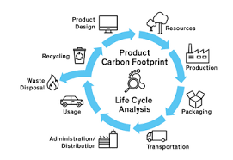
From https://www.myclimate.org/en/get-active/corporate-clients/product-carbon-footprints-pcf-and-life-cycle-assessments-lca-myclimate/
What is “Life Cycle Analysis” or LCA (Life Cycle Assessment)? And what is the purpose ?

