Energy Sources

Consult the following site :
- https://www.eia.gov/energyexplained/what-is-energy/sources-of-energy.php
And answer the questions below.

- Give the definition of energy source.

- Give the definition of a renewable energy source.

- What are the five sources of renewable energy ?

Consult the following site :
- https://solarpower.guide/solar-energy-insights/how-do-solar-panels-work
- https://actionrenewables.co.uk/news/how-does-a-wind-turbine-work/
- https://archive.epa.gov/climatechange/kids/solutions/technologies/geothermal.html
- https://www.youtube.com/watch?v=nVl17JLn_u0&ab_channel=GreenMountainEnergy
- https://www.eia.gov/energyexplained/hydropower/
And answer the question below.

- Explain how the different sources of renewable energy work.
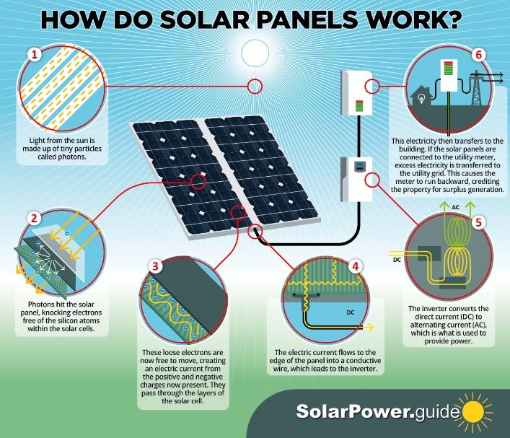
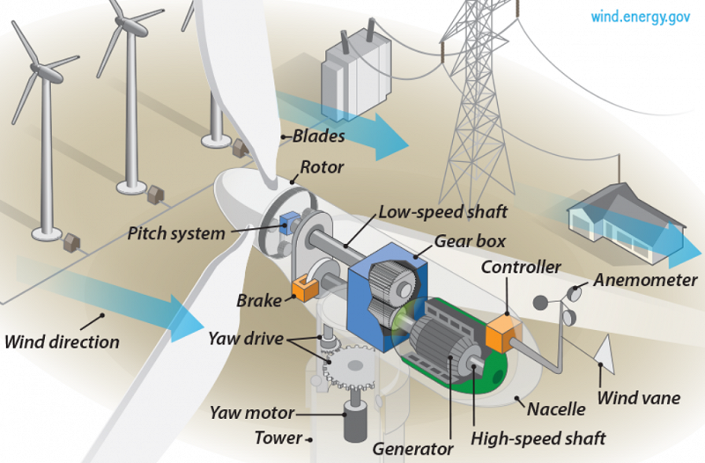
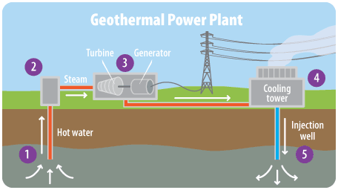
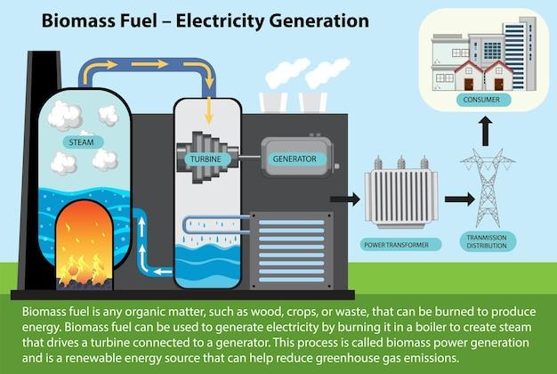
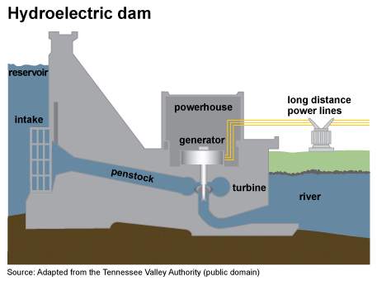

Consult the following site :
- https://app.electricitymaps.com/map
And answer the questions below.

- Explain the site in simple terms.

Click on "Production" and "Country" in the top right-hand corner. At bottom left, click on "Yearly" and choose the year 2025.
- Click on France. Complete the table below.
Geothermal
Biomass
Wind
Solar
Hydro
Total renewable:
Carbon intensity

- Click on Finland. Complete the table below.
Geothermal
Biomass
Wind
Solar
Hydro
Total renewable:
Carbon intensity

- Explain why Finland's carbon intensity is twice that of France, even though Finland produces twice as much electricity from renewable energy sources as France ?

- Which country has the best energy mix ? Explain.

